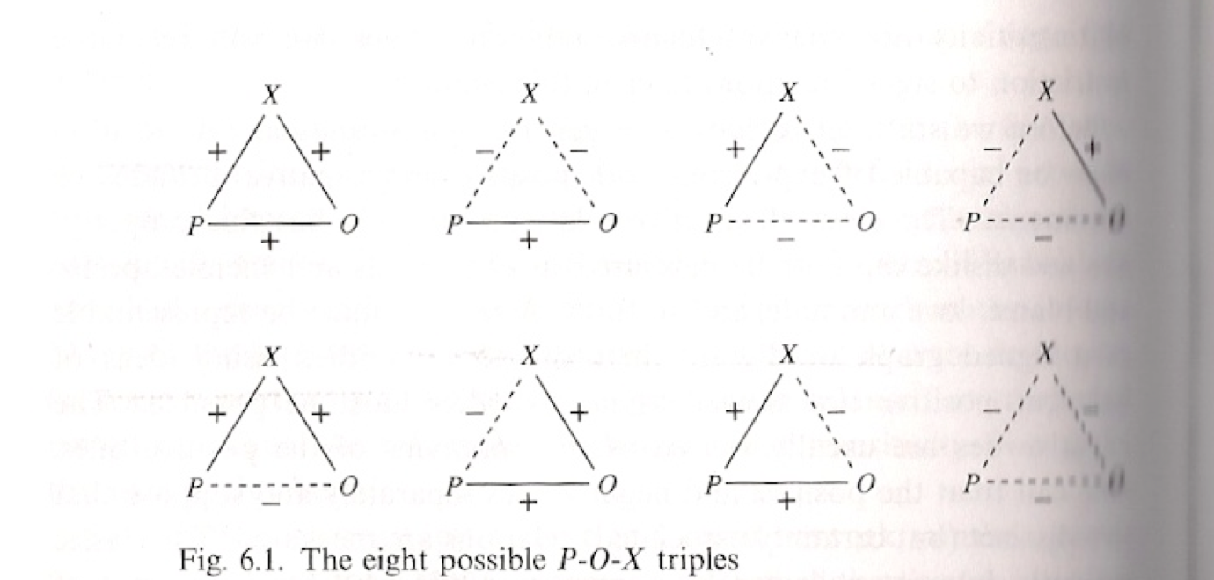

- Love anyone your friend loves
- Hate anyone your friend hates
- Hate anyone your enemy loves
- Love anyone your enemy loves

